Profiles.
The Hearing Laboratory at Essex has accumulated a useful number of auditory profiles for a range of people with good hearing or sensorineural hearing impairment. These profiles were collected using the multiThreshold software. This document describes how to access these profiles. The data were collected by Dr Wendy Lecluyse and Dr Christine Tan as part of their doctoral studies. Dr. Tan transcribed the data from the individual participant records to a more standard format using MATLAB .m files.
The profiles were collected from individuals with a sensorineural hearing loss (average age 59 years) as well as some young adults with good hearing (average age 32 years). Both groups consist of unpaid volunteers. Altogether, there are 77 participants; 23 with good hearing and 54 with impaired hearing. The average ages (with standard deviations) are, respectively, 32 (10) and 59 (11) years. The male/female ratio is approximately 3:2 in both cases.
The profiles and participant information are held in a profiles folder in the MAP1_14 software package. A readable representation of all the profiles, each presented as a separate chart can be found in a WORD document, profileSummary.doc.This document also contains some statistical analysis. For many, this will be all that is required to become familiar with the dataset. The rest of this document is for those who wish to investigate the profiles in greater detail.

The files
The complete collection of individual profiles (one per ear) is held in a subfolder called allParticipants. Each profile is held in a separate .m file so that each participant has two files. If only one ear was studied, the other ear file is empty. When the .m file is run it creates and returns a structure containing all of the data.
The name of each file consists of the word ‘profile_’, followed by the user’s code (e.g. ‘N03’) and then and ‘_R’ or ‘_L’ according to which ear was tested; for example, profile_N06_L is the profile for participant #6 with normal hearing. Or profile_I10_L for the left ear of participant #10 with impaired hearing.
These files are ‘raw data’ but even these are digests of more extended investigations. The data in the .m files are an attempt to introduce uniformity across participants in the presentation of available data. The original data is stored in Excel spreadsheets along with all of the testing details. These individual workbooks are available on request.
Participant details including participant numbers with age, gender, year of testing and whether or not tinnitus is present is given in an Excel spreadsheet called participantDetails.xls.
These data (the .m profiles and the participantDetails.xls) have also been consolidated into a single data file, called participantCompendium.mat. This compendium file is described later. The management of individual profile.m files is described first.
Participants are normally tested for three things; absolute thresholds, temporal masking curves (TMCs) and iso-forward masking contours (IFMCs). These are intended to be measures of sensitivity, compression and frequency selectivity, respectively and are described more fully in the multiThreshold Quick reference and Users manual.
Hearing dummies. Profiles generated by the auditory model ling software and handled separately. These are stored in a subfolder of ‘profiles’ called MTprofiles. This process is described in the documentation for multiThreshold and for MAP1_14. These files can also be processed using the software to be described but are not discussed further here.

plotProfile
A single file can be plotted using the plotProfile.m program found in the profiles folder. For example, the call
plotProfile('allParticipants', 'profile_N06_L')
plotProfile('allParticipants', 'profile_I10_L')
will generate the two following images
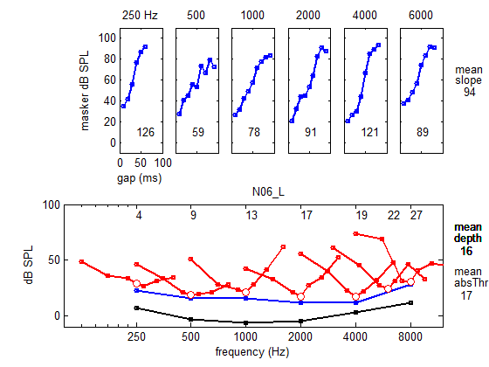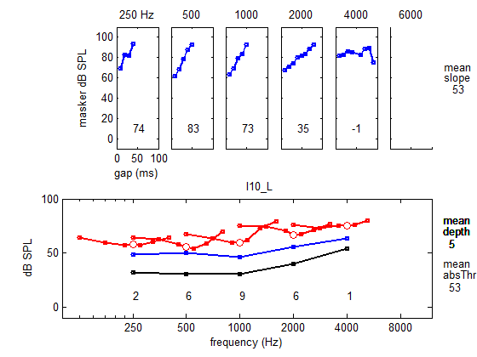
This function call has the following format
plotProfile (<folder name>, <file name>, <comparison file name>, <figure number>)
The last two arguments are optional. The <comparison file name> refers to a second file in the same folder that is plotted as background (using faint, dashed lines). In the following example, a profile for someone with a high frequency loss is compared with a young person with good hearing. The final argument, <figureNumber>, is mainly for use by calling programs.
plotProfile('allParticipants', 'profile_I10_L', 'profile_N06_L')
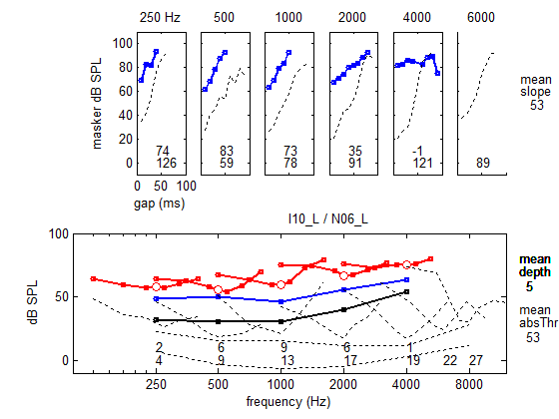
The visual profiles above show the results of attempts to quantify the shapes in the TMC and IFMC functions. The TMC measure is the slope of the best-fit straight line to the TMC data (in the top panels) expressed as dB/100ms. This is printed at the bottom of the upper panels. When two rows of figures are given, the upper row is the first (foreground) file. It can be seen that the good hearing profile has steeper slopes than the impaired profile but only at higher frequencies.
Our crude measure of frequency selectivity is quantified by the ‘depth’ of the V-shapes in the lower panel. This is computed as the average of the masker level at 0.7 and 1.3 times the probe frequency minus the masker level at the probe frequency (see diagram below). This simple metric gives large values when the IFMC is narrow and symmetric. These metrics are meant to be interpreted by comparison with values obtained from participants with good hearing. In the example above the good hearing profile has greater depth from 1000 Hz upwards.
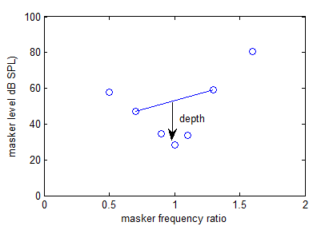
The numbers to the right of the plots are the averages across frequency for the first-named profile. The lowest figure to the right of the lower panel is the average absolute threshold for a long, 250-ms tone.

scanAllProfiles
scanAllProfiles.m is another program in the profiles folder. This will sequentially and rapidly plot all files in a specified folder followed by summary statistics. For example,
scanAllProfiles (‘impairedHearing’)
will process and summarise the data in a folder (in profiles) called impairedHearing. The summary statistics are computed across all participants for whom relevant data is available.
Two analysis figures are offered. The first, figure (6), shows the distribution of scores on three variables; absolute threshold, TMC slope and IFMC depth. These are subdivided according to the frequency tested. At the top of each subplot, summary statistics are shown; mean, standard deviation and sample size. The second, figure (5), shows scatter plots and correlations for each combination of these three measures. Again the analysis is performed separately for each probe frequencies used.
Summary statistics for all profiles are not very helpful. It is better to subdivide the profiles into specific groups according to interest. Subsets of the profiles (e.g. normal hearing profiles) can be copied and put into their own folders. Two folders, normalHearing and ImpairedHearing are given in the profiles folder for this purpose. scanAllProfiles can then be used to visualise and summarize the contents. For example
scanAllProfiles ('normalHearing')
scanAllProfiles ('impairedHearing')
summarise the results for both groups
Publish. When this program is used in conjunction with MATLABs ‘publish’ facility, it generates an HTML file containing all the profile images in a form that can be accessed using a browser. An example is given in the folder allParticipantsHTML. Enter the folder and click on scanAllFolders.html icon to open the document and view its contents. This facility was used as the basis for the profileSummary WORD document referred to earlier.
Careful scrutiny of these summary statistics can yield a great deal of information. However, another program exists, compareTwoProfileFolders, that compares the two groups more directly.
scanAllProfiles(‘normalHearing’)
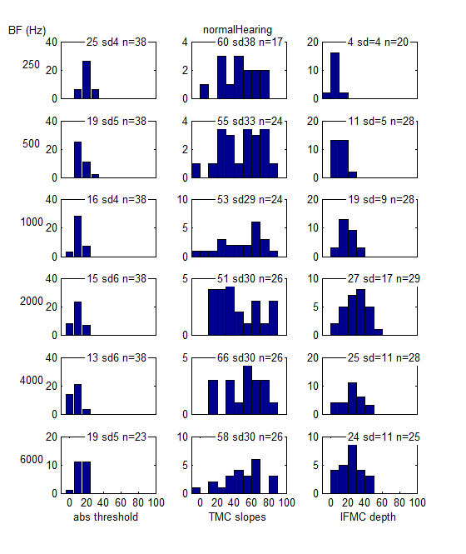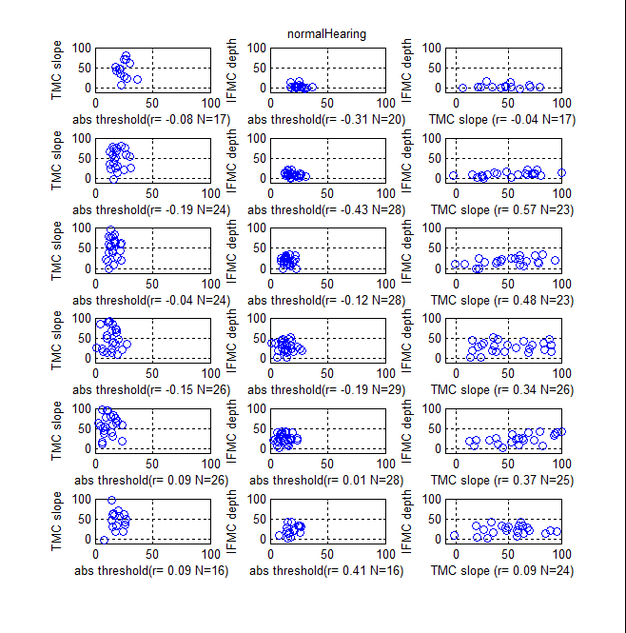
scanAllProfiles(‘impairedHearing)
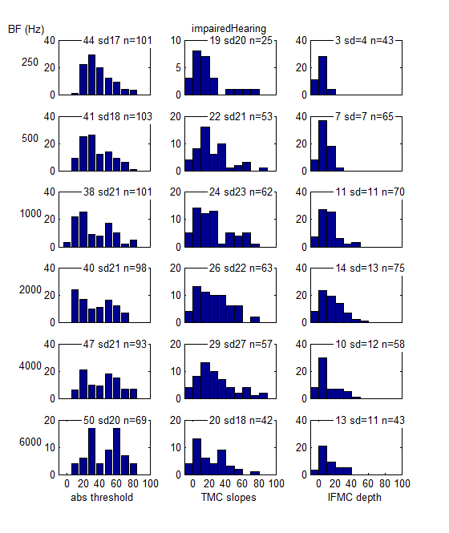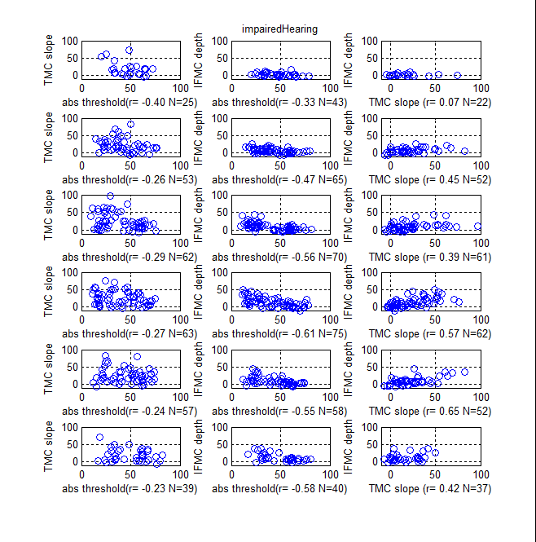

compareTwoProfileFolders
The following function uses scanAllProfiles twice to compare the files in two different folders. In this example all profiles from participants with normal hearing are grouped in a folder called ‘normalHearing’. The remainder are grouped in a folder called ‘impaired hearing.
compareTwoProfileFolders('normalHearing', 'impairedHearing')
This will have the same effect as scanAllFolders applied separately but also produces a summary figure that compares the two groups on the basis of the three measures. The error bars are standard deviations, showing the spread of the original scores.
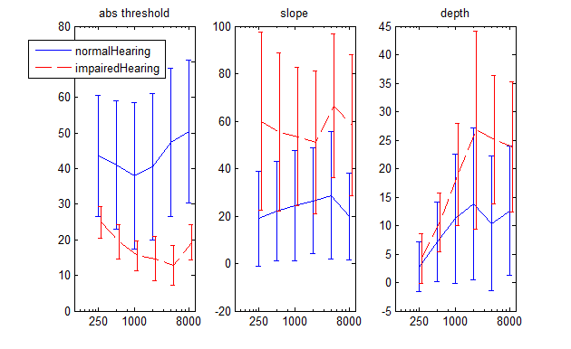
From this figure we can see that
- the absolute thresholds do not overlap between the groups
- the slopes of the TMCs do overlap considerably
- the TMC functions are shallower for the impaired group
- the TMC slopes do not change much with frequency
- the IFMC depth estimates are different between the two groups only at frequencies above 1000 Hz and, even then, there is considerable overlap even at these frequencies.

ParticipantCompendium
A .mat file called participantCompendium.mat contains structure consisting of all the participants along with other biographical information as well as the data for both the left and right ear. Navigate to the profiles folder and type in the command window
load participanList
This loads a single structure:
participant = 1x89 struct array with fields:

number
IH_NH
code
initials
ear
gender
DOB
birthYear
startTest
age
fullProfile
longProfile
shortProfile
tinnitus
hearingAid
aidType
conductiveLoss
leftEarData
rightEarData

The ear field (5th field) takes the values ‘R’ or ‘L’ or ‘RL’ according to whether both or only one ear was tested.

Simple conductive losses are not included in the database. However, where a conductive loss is present in addition to the sensorineural loss, this is indicated in the conductiveLoss field as a binary value. (currently this data is not present)

The following fields are also binary variables: fullProfile, longProfile, shortProfile. Three different measurement formats were used and the *profile fields indicate which one was used.

The fields, tinnitus and hearingAid indicate whether or not these apply to the participant. (currently, the hearing aid data is missing)

leftEarData and rightEarData fields contain structures containing the data returned by the individual profile .m files described above (and see the profile format section below)

Profile format
The profiles are written in .m files that pass a structure back to the calling program. A profile represents a single profile for a single ear. Two profile files are supplied, one for each ear, even if only one ear is measured.
The format is shown here only for the benefit of those who wish to create new profiles. The information is derived from the output of the multiThreshold software. At present, there is no automatic logging of the output in this format. The transcription needs to be performed manually. A fixed format is used and missing data are presented as NaN (not a number).
function x = profile_BCR_R
x.Comments= { };
x.BFs= [ 250 500 1000 2000 4000 6000 8000 ]; % frequencies of abs threshold tones
x.LongTone= [ 10.53 6.93 21.36 30.16 56.49 55.79 77.00 ]; % thresholds (dB SPL)
x.ShortTone= [
26.19 23.79 24.55 38.58 62.30 64.34 NaN ];

x.IFMCFreq= [ 250 500 1000 2000 4000 6000 8000 ]; % probe frequencies for IFMCs
x.MaskerRatio=[ 0.5 0.7 0.9 1 1.1 1.3 1.6 ]; % masker frequencies (relative to probe frequency)
x.IFMCs=[
NaN 41.38 40.50 44.14 66.92 NaN NaN
NaN 34.92 27.38 38.93 63.07 NaN NaN
NaN 31.17 32.05 43.87 66.58 NaN NaN
NaN 31.41 32.67 46.04 71.00 NaN NaN
NaN 39.61 18.04 49.21 71.86 NaN NaN
NaN 36.07 30.40 56.52 70.17 NaN NaN
NaN NaN 45.50 59.14 63.16 NaN NaN
]; % IFMC masker levels at masked threshold
x.IFMCs= x.IFMCs';
x.Gaps= [ 0.01 0.02 0.03 0.04 0.05 0.06 0.07 0.08 0.09 ]; % masker-probe gaps (s)
x.TMCFreq= [ 250 500 1000 2000 4000 6000 8000 ]; % TMC probe frequencies
x.TMC= [
NaN 44.09 34.07 49.06 73.70 NaN NaN
NaN 51.61 33.27 49.83 75.05 NaN NaN
NaN 57.10 35.62 50.78 79.35 NaN NaN
NaN 54.77 34.13 55.46 77.98 NaN NaN
NaN 58.47 40.27 54.48 79.94 NaN NaN
NaN 57.27 37.92 56.56 80.86 NaN NaN
NaN 60.05 42.35 57.36 80.32 NaN NaN
NaN 63.49 39.96 59.52 84.33 NaN NaN
NaN 61.22 42.01 60.33 86.97 NaN NaN
]; % TMC masker levels at masked threshold
x.TMC = x.TMC';

Average profiles
The script averageProfile.m can be used to find the average profile of all of the profile.m files of a particular type. Currently it is set up to average the good hearing profiles and generates the following image.
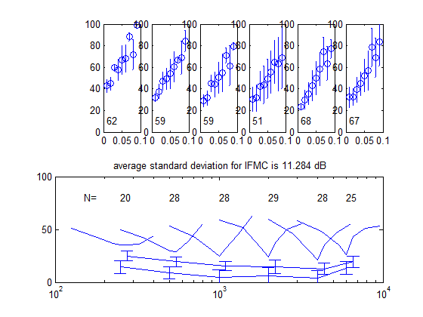
The error bars are standard deviations (not s.e.). Error bars are not included in the figure but the average value is given in the title to the lower panel. Inset numbers in the upper panel are best-fit slopes. ‘N=’ refers to sample sizes.
The program generates its own profile.m file and stores it in the allParticipants folder; in this case it is called averageNormal.m
The program fetches the participant profiles from the participantcompendium.mat file described above.

